Design and Implementation of D-Latch
Objective:
This circuit is also known as transparent circuit. That may use to store information in bits as they have two stable states. Latch can store 1 bit of information.
Theory: If C is 0, then the latch is disabled or ‘closed’ and the Q output retains its last value independent of the D unit.
The Table can be written as:
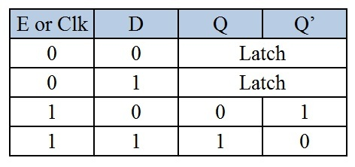
The circuit can be defined as
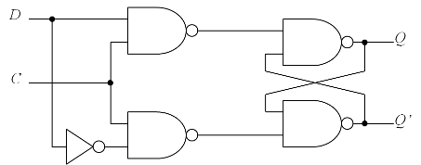
Circuit Diagram If D and Clk are in off state.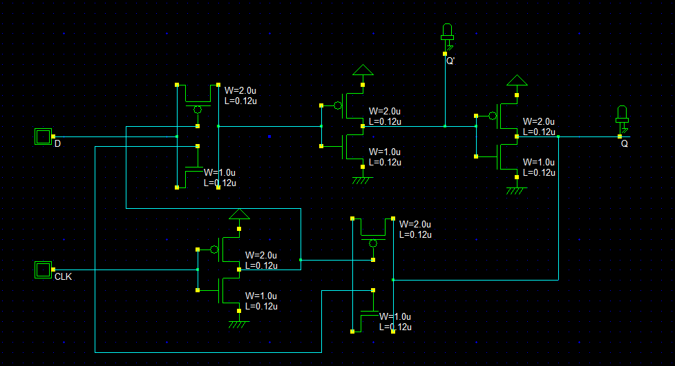
IF D and CLK are in a on state.
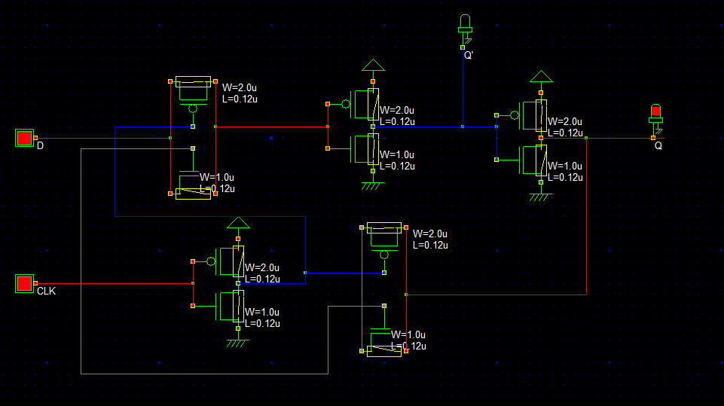
Verilog File
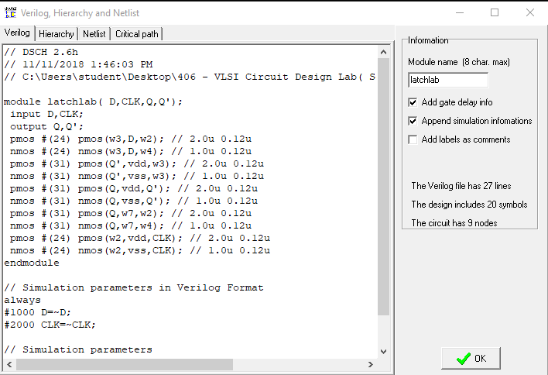
Layout Diagram

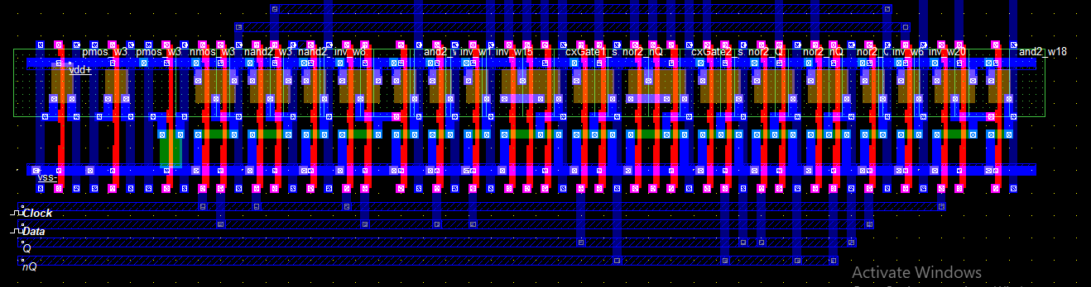

Stick Diagram

Timing Diagram
Discussion
From this d-latch implementation, we can find the output as two input with two output. One output is the vice-versa of the others output.

